MD RAJIB RARI

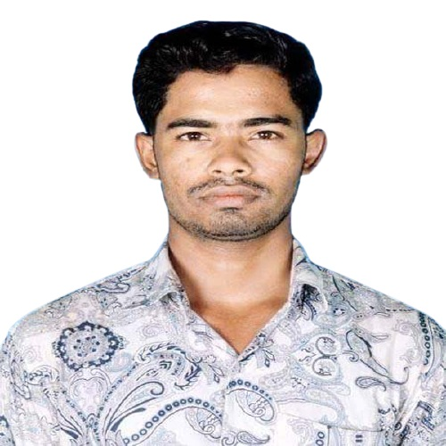

Vill**:** Chabua, P.O: Basarabad, P.St: Bauphal, Dist: Patuakhali

Dhaka, Bangladesh.

**E-mail:** [rajibhossen688@gmail.com](mailto:rajibhossen688@gmail.com).

**Phone No:** 01571365449.

**Git:** <https://github.com/rajib688>.

Objective:

* To achieve successful career through devotion, commitment and hard work an opportunity to work in an environment of excellence and challenge.

Self-Assessment:

* A Self-driven attitude, willingness to learn and a strong presence of mind.
* Optimistic, confident and benevolent.
* Energetic, devoted, sincere and hardworking.

Education:

|  |  |
| --- | --- |
| **Bachelor of Science in Computer Science and Engineering (B.Sc. in CSE).** | |
| University | Dhaka International University. |
| Session | 2017-2021. |
| Result | 3.51 Out of 4.00. |
| **Higher Secondary certificate (H.S.C).** | |
| Institute | Dr. Yakub Sharif College |
| Board | Barisal. |
| Group | Science. |
| Session | 2015-2016. |
| Result | GPA 3.92 Out of 5.00. |
| **Secondary School certificate (S.S.C).** | |
| Board | Barisal. |
| Group | Science. |
| Session | 2013-2014. |
| Result | GPA 4.06 Out of 5.00. |
| **Advanced English language Course.** | |
| Institute | Dhaka International University. |
| Result | GPA 3.50 Out of 4.00. |
| **C#.** | |
| Institute | Dev Skill. |
| **Web Application Development- Dot Net.** | |
| Institute | BASIS, SEIP. |
| **Business Excel.** | |
| Institute | BASIS & Pondit. |
| **Computer office Application.** | |
| Institute | Barnomala Computer training Center, Patuakhali. |
| Board | Technical. |
| Result | GPA 5.00 Out of 5.00. |
| **Institutional Quality Assurance Cell (IQAC).** | |
| Institute | Dhaka International University. |
| Workshop | Project management & its major aspects. |
| **Mujid Borsho IT Carnival 2020.** | |
| Institute | Dhaka International University. |
| Workshop | IOT and its prospects in Bangladesh. |
| **Mujid Borsho IT Carnival 2020.** | |
| Institute | Dhaka International University. |
| Workshop | Impact of machine learning in 4IR in Bangladesh. |

Core Skill’s:

* Programing language.
* C#, .Net Framework (N-tire, MVC)
* Front-end Design.
* HTML, CSS and JavaScript.
* SQL Server Operation.
* Operating System.
* Ubuntu (Linux), Windows7, Windows10.
* Basic Photoshop.
* Bangla & English typing.
* Microsoft Word, MS Excel, MS PowerPoint**.**
* Internet Browsing and Email Operations.
* Computer Proficiency with Internet Applications.
* Communication, interpersonal and organizational Skill.
* Can effectively work in a team.

Project:

* School Management System (Three Tires Architecture)
* Blood Bank (MVC Database First)
* Personal Portfolio
* Attendance System (Console Base C#)

Languages Proficiency:

* Speaking & Writing proficiency in both Bangla & English language.

Personal Profile:

|  |  |
| --- | --- |
| Father’s Name | Md Abul Rari. |
| Mather’s Name | Mosa Amena Begum. |
| Permanent Address | Vill: Chabua, P.O: Basarabad, P.S: Bauphal, Dist. Patuakhali. |
| Sex | Male |
| D.O.B | 31-12-1999. |
| Nationality | Bangladeshi. |
| Height | “5.5”. |
| Weight | 66 kg. |
| NID NO | 2854812548. |
| Blood Group | A+. |
| Religion | Muslim (Sunni). |
| Marital status | Un-married. |
| Interest | Traveling, Listing Music, Playing (Cricket), Browsing. |

Reference:

Md. Abdullah Al Mamun.

Trainer: DOT NET, BASIS, SEIP.

BDBL Bhaban, Kawran Bazar, Dhaka- 1215.

Phone No: 01718 742 594.

Email: mabdullah.developer@gmail.com.

Relative: Teacher.

Khandakar Mohammad Mohi Uddin.

Assistant Professor, Department of CSE.

Dhaka International University (DIU).

Phone No: 01520-102813.

Email: mohiuddin.cse@diu.ac

Relative: Teacher.

Thank You And Best Regards.

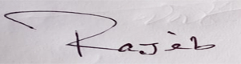

Md Rajib Rari